Digital Signal Processing
Year : 2016-17 Div : B.E. A,B,C

Lecture – 02

- List different operations that can be performed on Discrete Time signals. Give example for each.
- Solve graphically. ( denotes zero index position)
  - x1[n] = [1, 2, 3, 5, 6 ] + [0, -1, 2, -3]
  - x2[n] = [-1, -4, 0, 6 ] - [0, -1, 2, -3]
  - x3[n] = [1, 2, 3, 5, 6 ] * [0, -1, 2, -3]

Q1.)In this transformation, only the quadrature axis values are modified i.e magnitude of the signal changes, with no effects on the horizontal axis values or periodicity of signals like.
- Amplitude scaling of signals.
- Addition of signals.
- Multiplication of signals.
- Differentiation of signals.
- Integration of signals.

Amplitude Scaling of Signals
Amplitude scaling is a very basic operation performed on signals to vary its strength. It can be mathematically represented as Y(t) = α X(t). Here, α is the scaling factor, where:- α<1 → signal is attenuated. α>1 → signal is amplified. 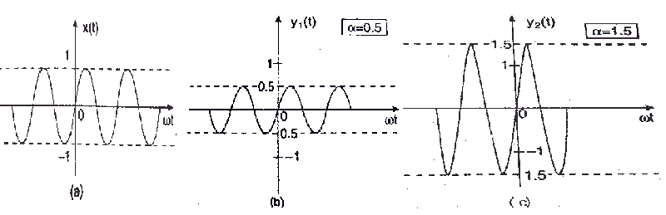This is illustrated in the diagram, where the signal is attenuated when α = 0.5 in fig (b) and amplified when α = 1.5 as in fig (c).

Addition of Signals
This particular operation involves the addition of amplitude of two or more signals at each instance of time or any other independent variables which are common between the signals. Addition of signals is illustrated in the diagram below, where X₁(t) and X₂(t) are two time dependent signals, performing the additional operation on them we get, Y(t) = X₁(t) + X₂(t) 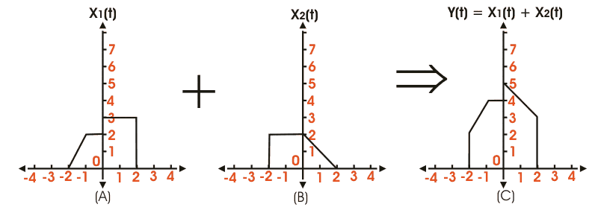

Multiplication of Signals
Like addition multiplication of signals also falls under the category of basic signal operations. Here multiplication of amplitude of two or more signals at each instance of time or any other independent variables is done which are common between the signals. The resultant signal we get has values equal to the product of amplitude of the parent signals for each instance of time. Multiplication of signals is illustrated in the diagram below, where X₁(t) and X₂(t) are two time dependent signals, on whom after performing the multiplication operation we get, Y(t) = X₁(t) X₂(t) 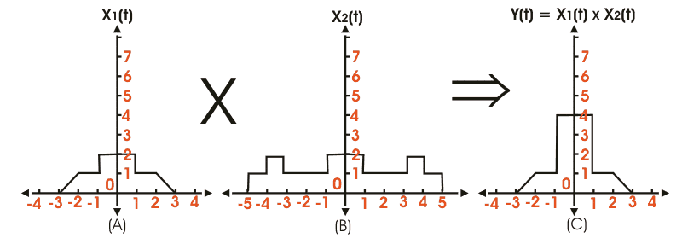

This is exactly the opposite of the above mentioned case, here the periodicity of the signal is varied by modifying the horizontal axis values, while the amplitude or the strength remains constant. These are:-
- Time scaling of signals
- Reflection of signals
- Time-shifting of signals.
Let us look into these operations in details.

Time Scaling of Signals
Time scaling of signals of signals involves the modification of a periodicity of the signal, keeping its amplitude constant. Its mathematically expressed as, Y(t) = βX(t) Where, X(t) is the original signal, and β is the scaling factor. If β > 1 implies, the signal is compressed. And β < 1 implies, the signal is expanded. This is illustrated diagrammatically for better understanding. 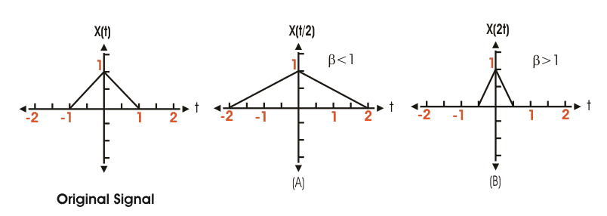

Reflection of Signals
Reflection of signal is a very interesting operation applicable on both continuous and discrete signals. Here in this case the vertical axis acts as the mirror, and the transformed image obtained is exactly the mirror image of the parent signal. It can be defined as Y(t) = X( - t) Where, X(t) is the original signal. But if the reflected signal X( - t) = X(t); then its called an even signal. Where as when X( - t) = − X(t); then its known as an odd signal.
its explained diagrammatically as, 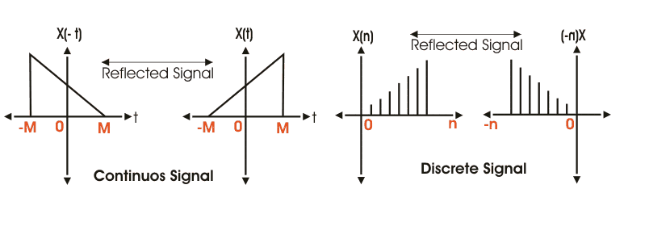

Time Shifting of Signals
Time shifting of signals is probably the most important one, and most widely used amongst all basic signal operations. Its generally used to fast-forward or delay a signal, as is necessary in most practical circumstances. Time shifting is mathematically expressed as, Y(t) = X(t - t₀). Where, X(t ) is the original signal, and t₀ represents the shift in time. For a signal X(t) if the position shift t₀> 0. Then the signal is said to be right shifted or delayed. In the same manner, if t₀< 0, implies the signal is left shifted or delayed. This has been explained diagrammatically in the figure below. Where the original signal fig(a) is right shifted and also left shifted in figure (b) and (c) respectively. 